**Stratagem Sports: Football**

**Universal Player Actions**

* How to Select Actions
  + When the user selects a player there is a circle of buttons to select like this referenced image.

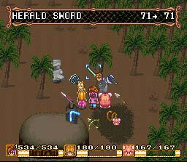

* + These buttons will be categories of options to select from, selecting actions will create a new circle of buttons to choose from.
* Action: Move
  + After selecting the move action a boundary the size based of the players stats appears.
  + When the user moves the mouse an arrow will be attached to it and follows it as long as it's in the players move boundary
  + Wherever the player clicks i the boundary a line will be made from the player to where the user clicked and the arrow will originate from that point creating a new boundary for continued movement.
* Action: Block(Offensive).
  + After Selecting the block action a square will appear under the cursor but will be red unless it is adjacent to the player or the end of the players movement.
  + If the box the user selects is occupied by an opponent's player the player will block them immediately but if the box has no opponent in or adjacent to it the player will block the opponents player who comes closest to where the box is placed that is unblocked.
* Action: Tackle(Defensive)
  + After selecting the tackle action a square will appear under the cursor
  + If the box the user selects is occupied by an opponent's player and that player has the ball the player will move to the player and tackle the opponents player.
  + If the opponent player with the ball moves the player will follow the player this will also happen if the opponents player hands the ball to another opponent player following the new opponents player who took the ball.